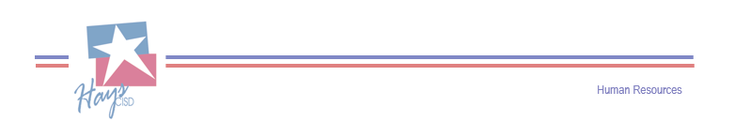

**Qualifying Life Event (QLE) Information**

(For changes during the plan year ***outside*** of open enrollment)

* Under Section 125, any “pre-tax” elections will remain in effect and ***cannot*** be revoked or changed during the plan year, unless the participant experiences a Qualifying Life Event (QLE).
* The participant must make the change within 31 calendar days of the QLE.
* It is **prohibited** to switch plans during the plan year. The QLE only allows for modifications of dependents to the employee’s current plan.
* Premiums are not prorated.

**IMPORTANT:** If the employee misses the QLE enrollment deadline, the QLE will be denied. This means dependents cannot be added until the next enrollment period.

**NOTE:** Documentation is required for changes. Documentation when faxed or emailed is time stamped and will be considered whether the Human Resources offices is open or closed. See below for QLE and documentation examples.

**QLE EX. 1** – Adoption

* + - Placement for adoption paperwork or legal documentation of adoption.

**QLE EX. 2** – Birth of a Child

* + - Birth certificate or verification of birth facts issued by the hospital or birth center.

**QLE EX. 3** – Death

* + - Death certificate or formal proof of death.

**QLE EX. 4** – Dependent’s enrollment in another employer’s benefits through job change or open enrollment

* + - Proof of enrollment **must include all** of the following: Name of the dependents covered with the effective date/s, proof of the coverage type, medical/dental/vision, etc..

**QLE EX. 5** – Divorce

* + - Certified copy of divorce decree.

**QLE EX. 6** – Loss of benefits due to loss of job or loss of eligibility

* + - Proof of benefit termination **must** show the following: Names of dependents affected, coverage termination date/s and the type of coverage lost, medical/dental/vision, etc..

Questions or concerns can be sent to the Human Resources Department at:

[InsuranceBenefits@hayscisd.net](mailto:InsuranceBenefits@hayscisd.net) or 512-268-7384 ext. 46026